[](https://www.google.co.in/url?sa=i&url=http://newhorizonindia.edu/nhengineering/wp-content/uploads/2018/02/mba-syllabus-10th-feb-2018-final-1.pdf&psig=AOvVaw0uQhiCLyvplhhU1vbOaxYi&ust=1573707996092000&source=images&cd=vfe&ved=0CAIQjRxqFwoTCNCe9aO15uUCFQAAAAAdAAAAABAJ)

**DEPARTMENT OF ELECTRICAL AND ELECTRONICS**

**MINI PROJECT**

**ULTRASONIC SENSOR BASED GLOVES**

**GROUP MENTOR**

**Dr. B. GUNAPRIYA**

**SUBMITTED BY:**

MANOJ KUMAR M B (USN: 1NH18EE028)

NIRANJAN KUMAR (USN: 1NH18EE038)

SHEKAR V (USN: 1NH18EE054)

**ULTRASONIC SENSOR BASED GLOVES**

**CERTIFICATE**

This is to certify that Manoj Kumar M B, Niranjan Kumar, Shekar V bearing USN: 1NH18EE028, 1NH18EE038, 1NH18EE054 respectively have submitted mini project titled

**“ULTRASONIC SENSOR BASED GLOVES ”**in partial fulfilment for the course of the EEE Department.

This report has been prepared as per the given format and is approved for the submission and presentation.

Signature of the **GUIDE** Signature of the **HOD**

(Dr. B.Gunapriya ) (Dr. Ramkumar S)

**ACKNOWLEDGEMENT**

It is indeed a great pleasure to recall the people who have helped me in carrying out this project. Naming all the people who have helped me in achieving this goal would be impossible, yet I attempt to thank a selected few who have helped me in diverse ways.

I wish to excess my sincere gratitude to **Dr. Manjunatha, Principal,** NHCE, Bangalore, for providing me with facilities to carry out this project.

I wish to express my sincere gratitude to **Dr. S Ramkumar, Head of the Department,** Electrical & Electronics Engineering, for his constant encouragement and cooperation.

I wish to express my sincere gratitude to my teacher and guide **Dr. B Gunapriya,** Associate Professor in the Department of Electrical & Electronics Engineering, NHCE, for her valuable suggestions, guidance, care & attention shown during the planning, conduction stages of this project work.

I express my sincere thanks to project coordinators, all the staff members and non-teaching staff of Department of Electrical & Electronics Engineering, for the kind cooperation extended by them.

I thank my parents for their support and encouragement throughout the course of my studies.

**ABSTRACT**

Third eye for the blind or Ultrasonic sensor based gloves is an innovation with the help of the multidiscipline subjects lie computer science, electronics engineering and health science which helps the blind people to navigate with speed and confidence by detecting the nearby obstacles using the help of ultrasonic waves and notify them with a buzzer sound or vibration. According to WHO 39 million people are estimated as blinds worldwide. They are suffering a lot of hardships in their daily life. The affected ones have been using the tradition white cane for many years which although being affective, still has a lot of disadvantages. This will be a wearable technology for the blinds. One of the main peculiarity of this device is that it will be affordable. This will be equipped with ultrasonic sensors, consisting of module. Using the sensor, visually impaired can detect the object around them and can travel easily. When the sensor detects any objects it will notify the user by beep or vibration. Thus this is an automated device. Thus this device will be great use for the blinds and help them travel different places.

**KEWORDS:** wearable band, buzzer, blind, ultrasonic, obstacles

**INTRODUCTION**

With the improvement of the living standards of the people, we have become so materialistic that we have forgotten how the physically disabled people live a tough life. They undergo rigorous, apathetic, and indifferent behavior towards them for being physically disabled. So for blind people going around to places in such environment is a very big challenge because the blind people cannot depend on their own eyes and thus face many difficulties.

The project **Ultrasonic Sensor Based Gloves** is to design a product which is very much useful to those people who are visually impaired and those who often have to rely on others. Our project model is a wearable band which produces ultrasonic waves which detects any obstacles in front of them with buzz sound or vibrations. However, all the existing systems inform the blind the presence of the object at a specific distance in front of or near to them. There are some limitations, but to overcome it this work offers a simple, efficient, configurable virtual for the blind.

**OBJECTIVE**

The objective of this project **Ultrasonic Sensor Based Gloves** is to design a product which is very much useful to those people who are visually impaired and those who often have to rely on others. Our project model is a wearable band which produces ultrasonic waves which detects any obstacles in front of them with buzz sound or vibrations. However, all the existing systems inform the blind the presence of the object at a specific distance in front of or near to them. There are some limitations but to overcome it this work offers a simple, efficient, configurable virtual for the blind

**COMPONENTS**

* LED
* Battery
* Ultrasonic sensor
* Vibration sensor
* Resistor
* Buzzer

**RESISTOR**

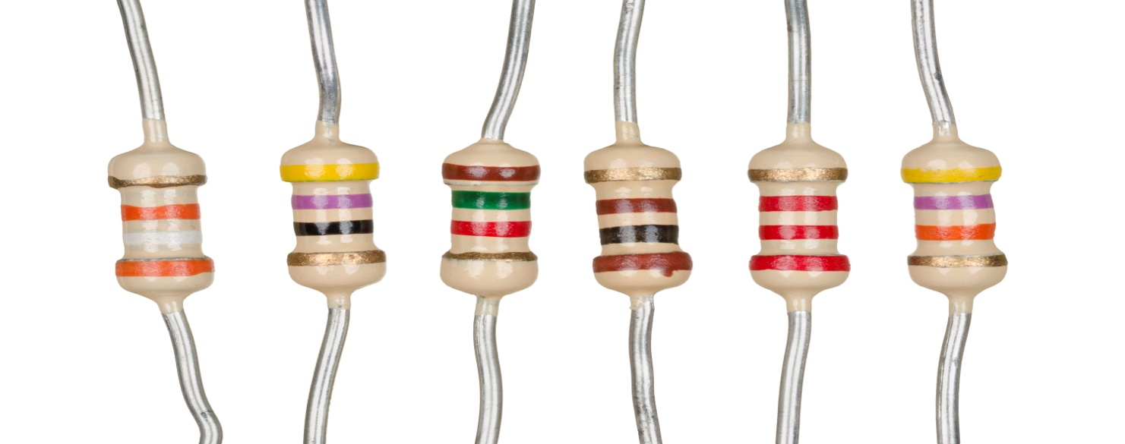

A resistor is a passive two-terminal electrical component that implements electrical resistance as a circuit element. In electronic circuits, resistors are used to reduce current flow, adjust signal levels, to divide voltages, bias active elements, and terminate transmission lines, among other uses.

High-power resistors that can dissipate many watts of electrical power as heat, may be used as part of motor controls, in power distribution systems, or as test loads for generators. Fixed resistors have resistances that can only change slightly with temperature, time or operating voltage. Variable resistors can be used to adjust circuit elements, or as sensing devices for heat, light, humidity, force, or chemical activity.

**ULTRASONIC SENSOR**

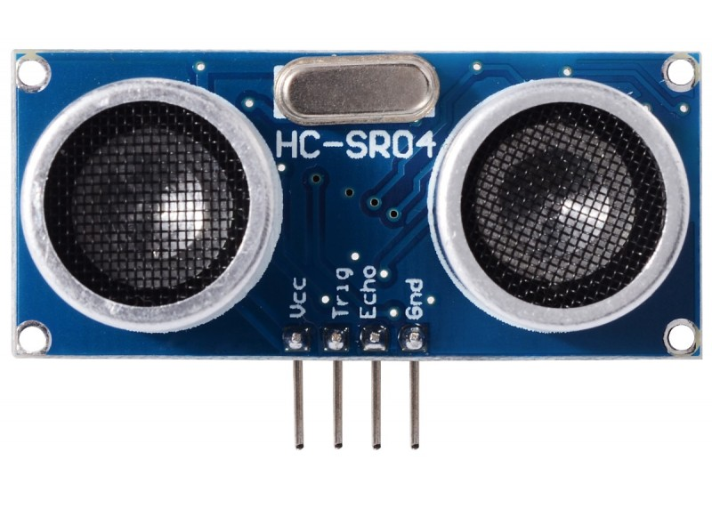

Ultrasonic sensors work by emitting sound waves at a frequency too high for humans to hear. They then wait for the sound to be reflected back, calculating distance based on the time required. This is similar to how radar measures the time it takes a radio wave to return after hitting an object.

While some sensors use a separate sound emitter and receiver, it’s also possible to combine these into one package device, having an ultrasonic element alternate between emitting and receiving signals. This type of sensor can be manufactured in a smaller package than with separate elements, which is convenient for applications where size is at a premium.

While radar and ultrasonic sensors can be used for some of the same purposes, sound-based sensors are readily available—they can be had for just a couple dollars in some cases—and in certain situations, they may detect objects more effectively than radar.

**VIBRATION SENSOR**

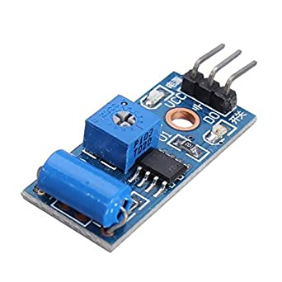

Vibration sensors are piezoelectric accelerometers that sense vibration. They are used for measuring fluctuating accelerations or speeds or for normal vibration measurement. Maintenance professionals use the sensors in order to predict the maintenance of the machinery, to reduce overall costs and increase the performance of the machinery.

Examples of applications where the vibration sensors are used: process control systems, aerial navigation and underwater-applications. Frequency ranges from 0.2 up to 2500 Hz. The operating temperature of these sensors is between -50°C and +85°C.Under acceleration, the mass causes a shear stress to be applied to the **sensing** crystals. This stress results in a proportional electrical output by the piezoelectric material.

**WORKING**

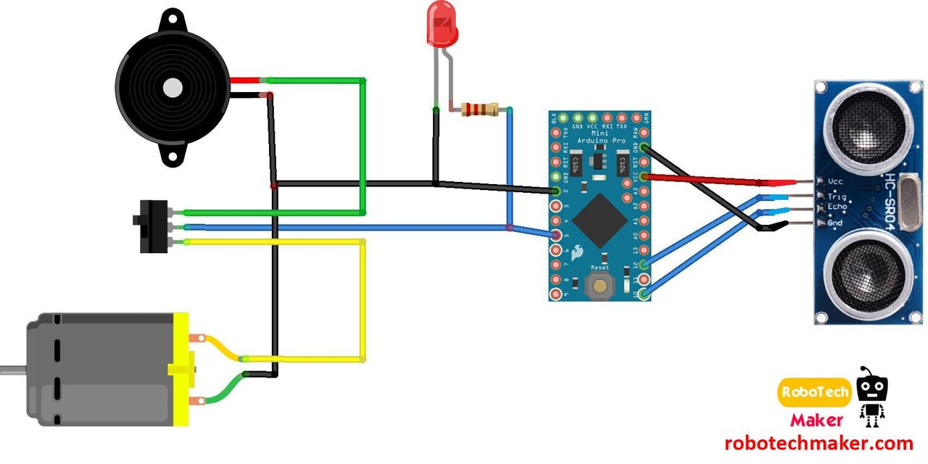

This proposed system consists the equipment like ultrasonic sensor, pref board, vibrating motor, buzzers for detecting the obstacles and letting the user know about the obstacle, LEDs, switches, male and female header pins and a battery. The ultrasonic sensor are wired accordingly which is a transducer, and is used in pair as transceiver. The transmitter emits the US waves and if obstacles are present in the path, the US waves hits the obstacles and gets reflected back, the reflected wave is received by the receiver. The US sensor is combination of one transmitter and receiver. The time interval between sending and receiving of the US signal is calculated, this time interval is used to calculate the distance between sensor and the obstacle.

Sensor has a field of view of about 60 degrees for 4 feet distance, as the distance from the sensor increases, the covering angle decreases. Thus, this way the Ultrasonic Sensor based Gloves will be designed for the visually impaired people and will make it very easy and convenient as it will be a wearable device and thus will help the user in travelling and detecting the while walking very easily.

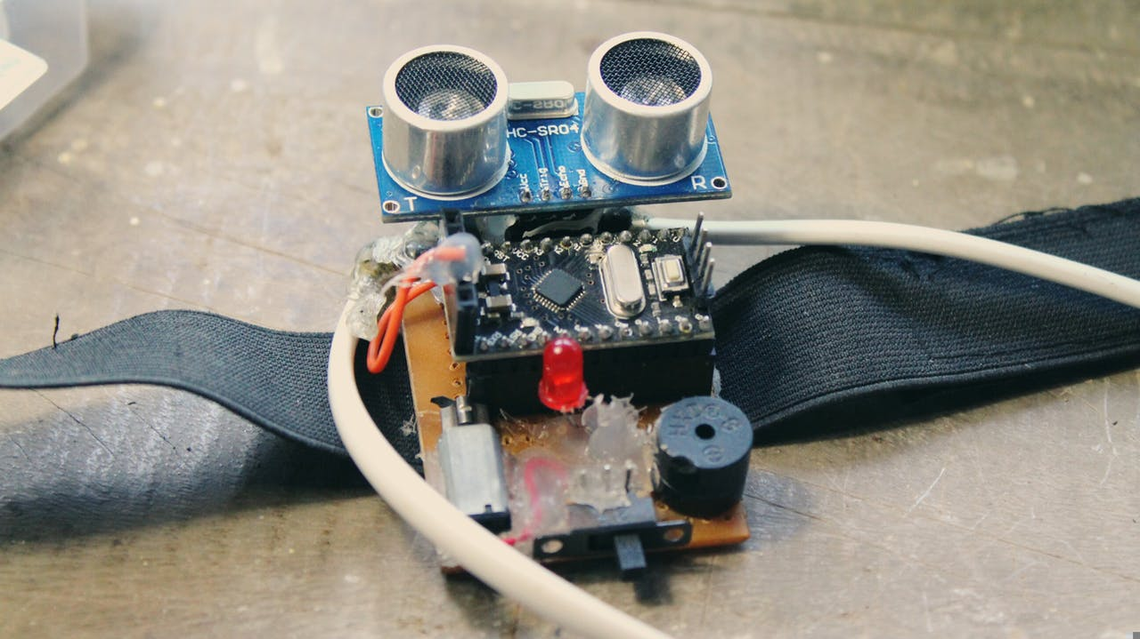

* The first wearable technology for people who are blind
* Using ultrasonic waves to detect the obstacles
* Notifying the user through vibrations/buzzer sound

Third eye for people who are blind is an innovation which helps the blind people to navigate with speed and confidence by detecting the nearby obstacles using the help of ultrasonic waves and notify them with buzzer sound or vibration. They only need to wear this device as a band or cloth.

According to WHO 39 million peoples are estimated as blind worldwide. They are suffering a lot of hardship in their daily life. The affected ones have been using the traditional white cane for many years which although being effective, still has a lot of disadvantages. Another way is, having a pet animal such as a dog, but it is really expensive. So the aim of the project is to develop a cheap and more efficient way to help visually impaired to navigate with greater comfort, speed and confidence.

**Problem of the Existing Systems**

* White cane - May easily crack/break, the stick may get stuck at pavement cracks of different objects.
* Pet dog - Huge cost. (280000Rs )
* Common Disadvantages (Including the smart devices) Cannot be carried easily, needs a lot of training to use

The features of Third eye for blind people: By wearing this device they can fully avoid the use of white cane and such other devices. This device will help the blind to navigate without holding a stick which is a bit annoying for them. They can simply wear it as a band or cloth and it can function very accurately and they only need a very little training to use it.

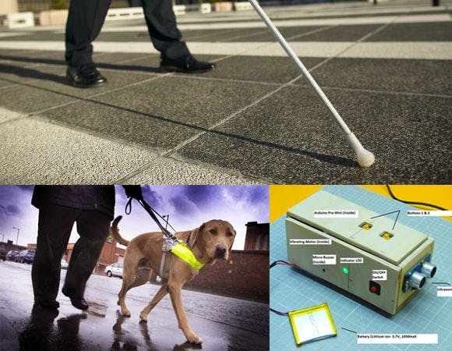

**APPLICATIONS**

* Detection of known objects or obstacles
* Affordable for all.
* Light weighed.
* Easy to carry.
* Pocket sized model.

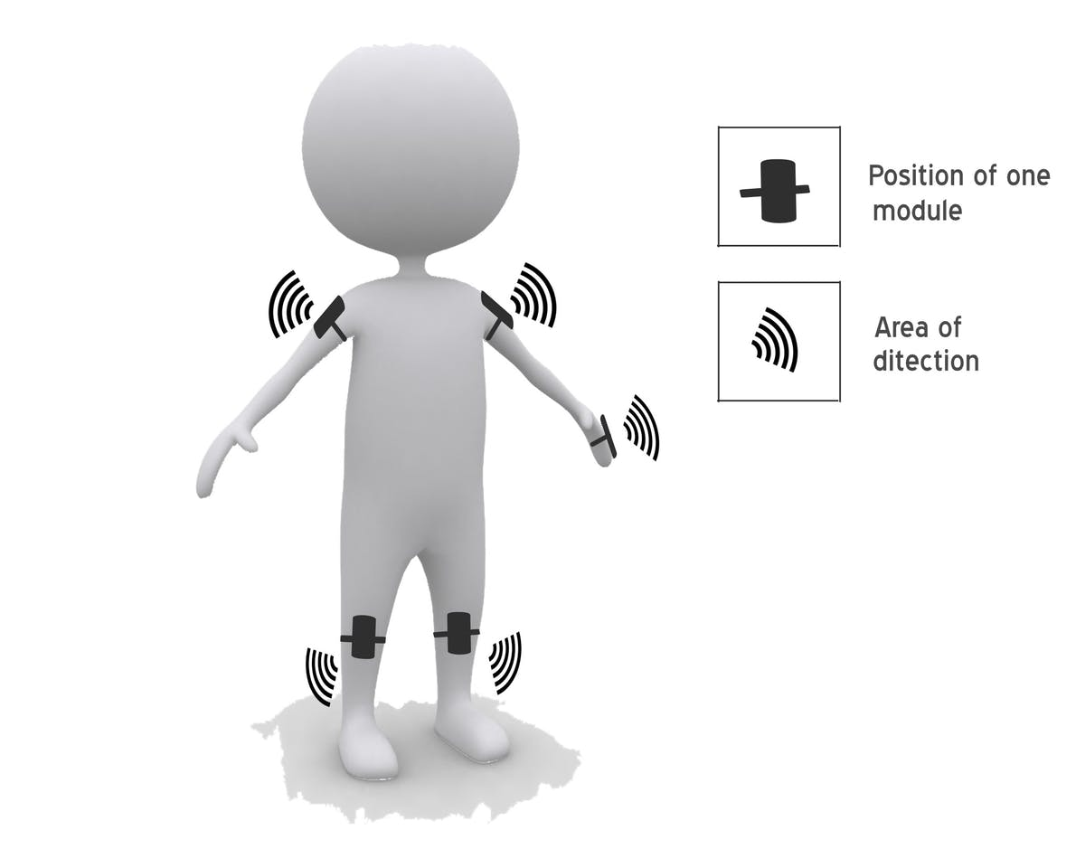

**LITERATURE SURVEY**

1. “Third eye for blind”, National Journal of Multidisciplinary Research and Development, 2017, [www.nationaljournals.com](http://www.nationaljournals.com)
2. “Ultrasonic sensor based gloves”, 2018, [www.projecthub.com](http://www.projecthub.com)
3. “Ultrasonic sensor based gloves”, International Journal of Computer Architecture and their Applications (IJNCAA), 2016, [www.ijncaa.com](http://www.ijncaa.com)
4. Benjamin JM, Ali NA. “A laser cane for the blind”, Proceedings of San Diego Medical Symposium, 1973.
5. “Third eye for blind”, Circuit-Projects.com Quality Circuits Archive. Accessed March, 2009. <http://www.circuit-projects.com>

**CONCLUSION**

Thus, this project proposed the design and architecture of a new concept of Ultrasonic sensor based gloves for the blind people. A simple, cheap, efficient, easy to carry, configurable, easy to handle electronic guidance system with many more amazing properties and advantages is proposed to provide constructive assistant and support for the blind and visually impaired people. With the proposed architecture, if constructed with at most accuracy, the blind will be able to move from one place to another without others help.